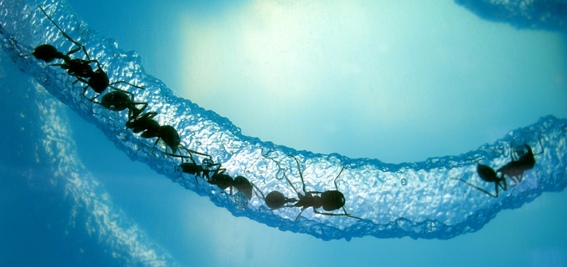
REGISTRATION FORM
http://sciencemathsconference2015.weebly.com

SCIENCE AND MATHS CONFERENCE 2015
COLLABORATION AND NETWORKING
16 and 17 October, 2015
NAME: Click here to enter text.
SCHOOL:Click here to enter text.
ADDRESS:Click here to enter text.
POSITION AT SCHOOL:Click here to enter text.
TYPE OF REGISTRATION (please choose one)
Early bird registration (must be registered before 31 July, 2015)
Full two day registration including dinner $450
Two day registration without dinner $400
One day registration including dinner $320
One day registration without dinner $270
Regular registration (registration after 5 June, 2015)
Full two day registration including dinner $540
Two day registration without dinner $480
One day registration including dinner $400
One day registration without dinner $310

Please send your completed registration form to Cherine Spirou (cherine.spirou@det.nsw.edu.au)
We will send an invoice once we receive your registration.
If you wish to pay by cheque, please make them payable to:
Fairvale High School
Thorney Rd
Fairfield West.
NSW 2165
If you prefer to pay by Direct Deposit, bank details are as follows:
Bank: WESTPAC
BSB No: 032-001
Account Details: 13-9895
PLEASE NOTE: Accomodation is at your own expense and responsibility. However, as part of the conference delegation, you will be provided with a discount conference price for the evening – all you have to do is mention that you are attending the Science and Maths Conference. If there are any questions, please contact me via email.
Thanks
Cherine Spirou
(LMC Co-ordinator)

